Development of an Interactive Flutter App
1. Installation of Visual Studio Code (VS Code)
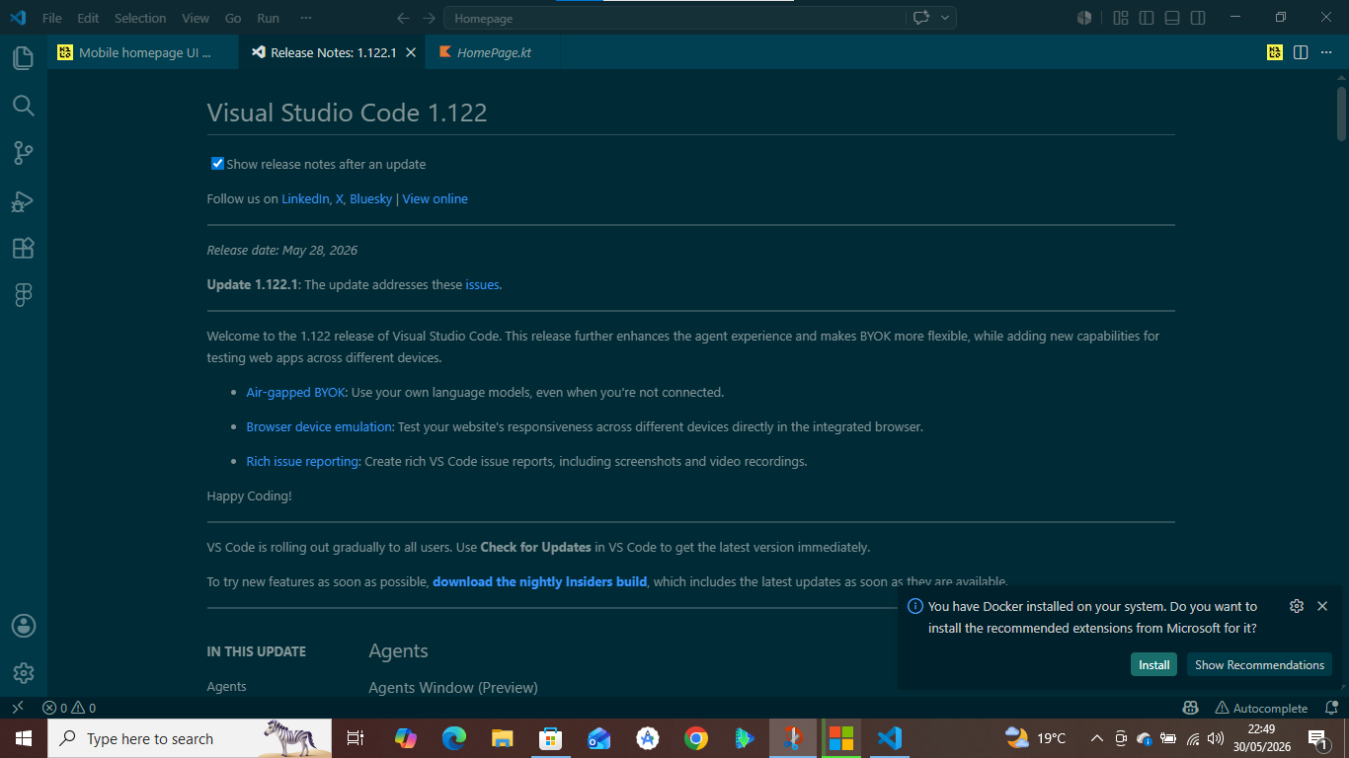
- Downloaded and installed Visual Studio Code version 1.122 as shown in the update screenshot.
- During setup, the system prompted to install recommended Docker extensions, but this was optional for Flutter development.
2. Installing Flutter and Dart Extensions in VS Code
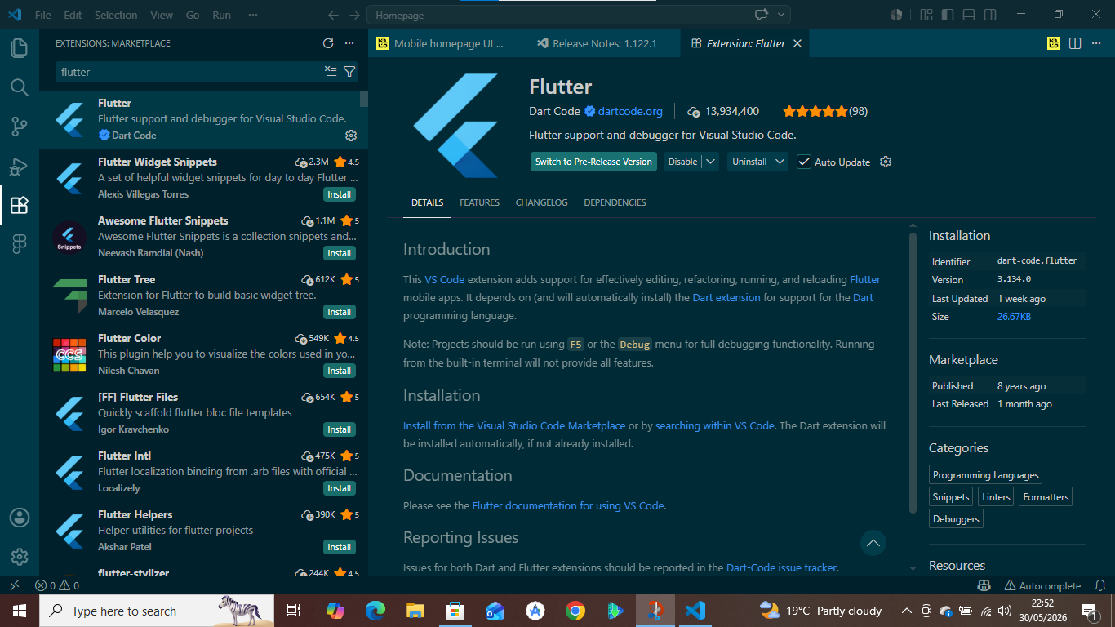
- Opened VS Code and navigated to the Extensions Marketplace.
- Searched for and installed the official Flutter extension (by Dart Code, version 3.134.0). The Dart extension was installed automatically as a dependency.
- Additional helpful extensions were available (e.g., Flutter Widget Snippets, Flutter Tree), but the core requirement was the official Flutter/Dart support.
3. Verifying the Development Environment using Flutter Doctor
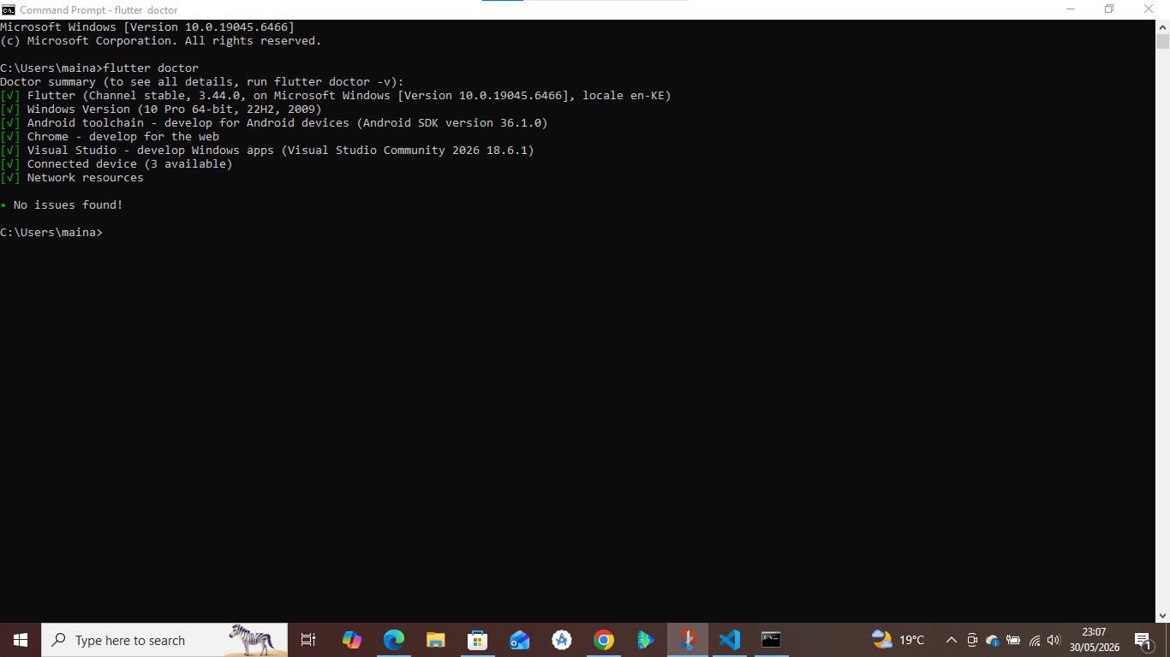
- Opened Command Prompt (cmd) as shown or terminal in VS code
- Ran the command: flutter doctor
- The output confirmed no issues:
  - Flutter SDK (stable channel, version 3.44.0) was installed.
  - Chrome and Edge were available for web testing.
  - Android toolchain and Visual Studio for Windows development were correctly configured.
  - Connected devices: Windows, Chrome, and Edge were detected.
4. Creating the Flutter Project in Vs Code
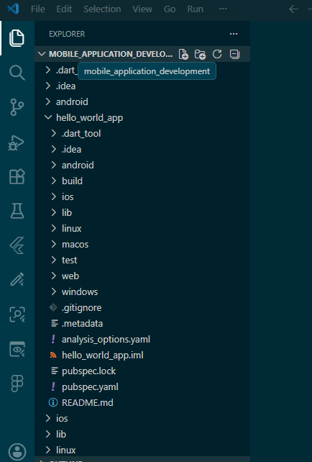
- In VS Code, created a new Flutter project named my_first_flutter_app
- The project location was: C:\Users\BEST\Documents\FlutterProjects\assignment-1-students-should-1-install\my_first_flutter_app
5. Source code of the flutter project
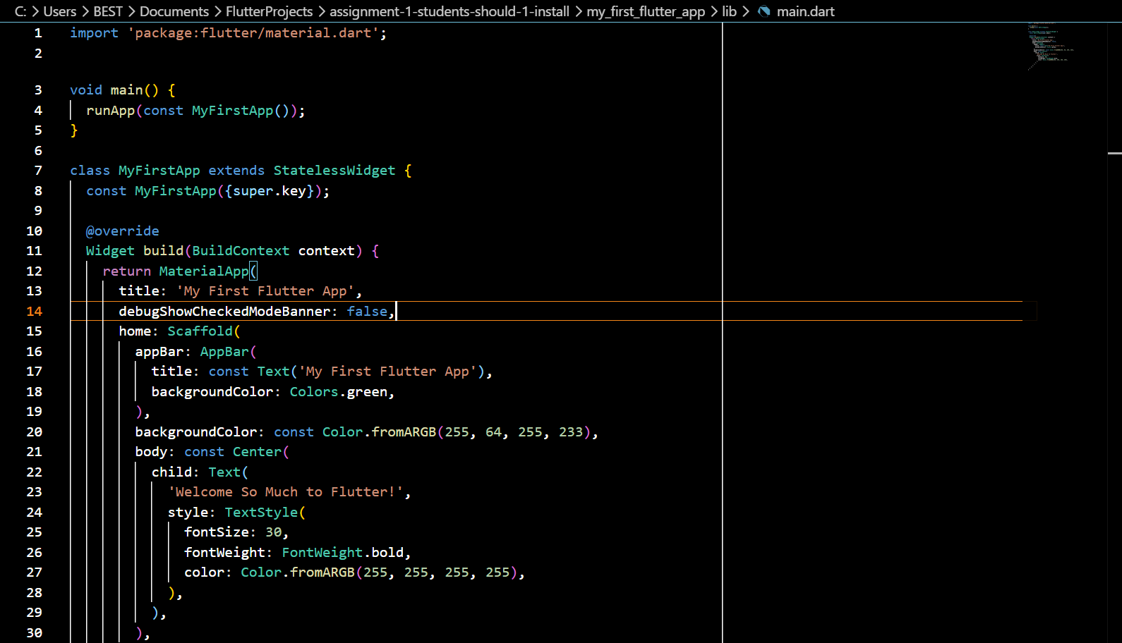

- Developed a StatefulWidget to manage interactive elements.
- Key features implemented:
  - A TextField for user input.
  - A Text widget to display output.
  - A button that, when clicked, shows the typed text.
  - A second button that randomly changes the background color of the app bar or container.
6. Running the Application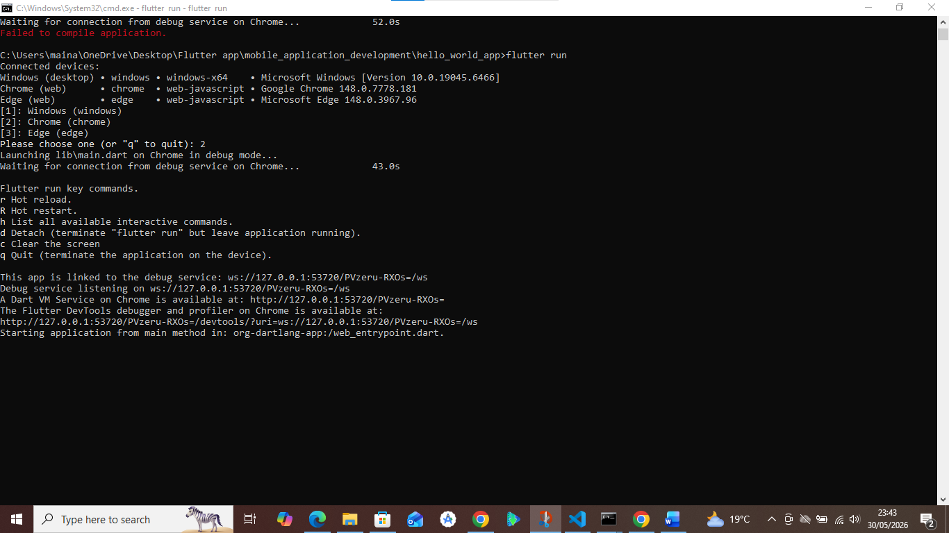
- In the terminal (cmd or VS Code terminal), ran the command: flutter run
- The system detected multiple devices: Windows, Chrome, and Edge.
- Selected Chrome (Option 2) for web testing.
7. Final Outcome
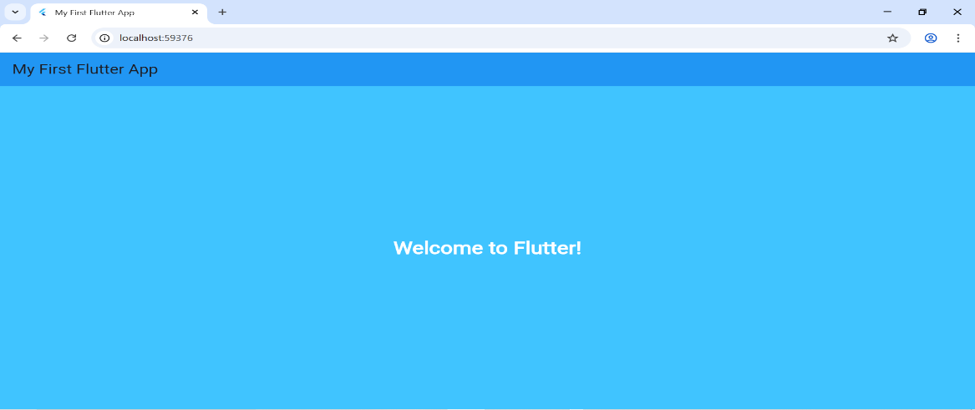
I Successfully set up a Flutter development environment in VS Code, created a project, wrote interactive code with input/output and color-changing functionality, and ran it on a Chrome web browser as my emulator with full debug capabilities.
WEEK 2: MINI STUDENT MANAGEMENT APP
App Name: Student_management_app
Framework: Flutter
Database: JSON APIs and SQLite
1.PROJECT INITIALIAZATION
First, I prompted the flutter to create a new project named student management and it downloaded all the dependencies need.
The Following are the project directory and file structure established within the lib/ folder:
lib/
├── main. Dart # Student-only routing
├── database/
│ └── database_helper. dart # SQLite helper (students only)
├── models/
│ └── student. Dart # Student model class
├── screens/
│ ├── student_login_screen. dart # Student login form
│ ├── registration_screen. dart # Student registration/edit form
│ └── student_dashboard_screen. dart # Student profile view
├── utils/
│ └── app_theme. dart # Your theme/colors
1.Project Overview
- A mini student portal built with Flutter.
- Students can register, log in, and access a dashboard showing their details.
- Uses SQLite for local data storage and Shared Preferences for session persistence.
- Designed as a student-only system.
2. Core Features
- Registration Screen: Students enter name, email, student ID, and course. Data is saved in SQLite.
- Login Screen: Students log in using their Student ID + Email.
- Dashboard Screen: Displays student details after login.
- Auto-login: If a student is already logged in, the app routes directly to the dashboard.
- Validation: Input fields check required values and valid email format.
3. Technical Stack
- Flutter (UI framework).
- SQLite (SQLite + sqflite_common_ffi) for database storage.
- Path package for database file paths.
- Shared Preferences for session management.
4.FINAL OUTCOME
4.1: Registration Screenshot
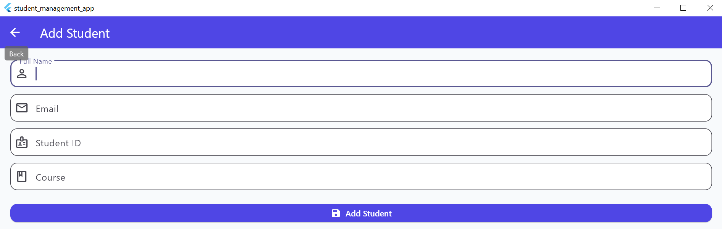
4.2: Login Screenshot
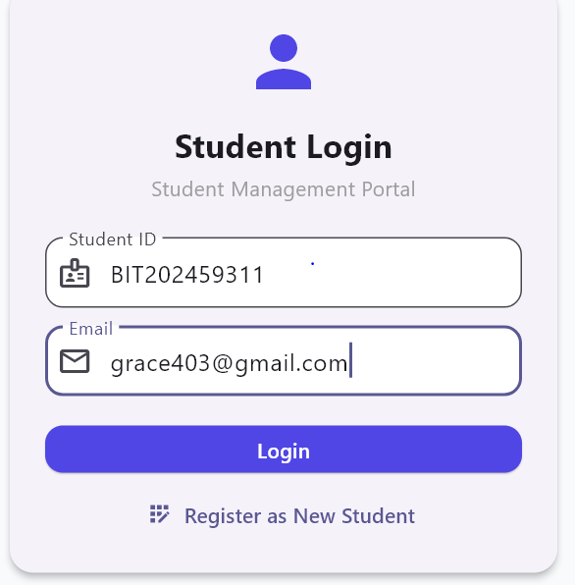
4.3: Dashboard Screenshot
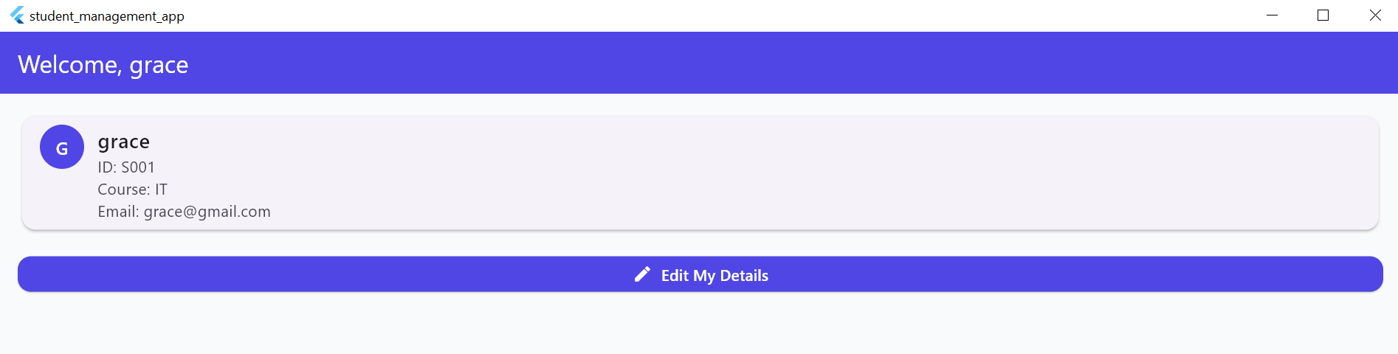

WEEK 3: USHIRIKA SACCO APP FIGMA DESIGN +FLUTTER
1. Project Initialization
I created a new Flutter project named ushirika_sacco_app. The following is the project directory and file structure established within the lib/ folder:
Code
lib/
ushirika_sacco_app/
├── pubspec. yaml
└── lib/
├── main. Dart
├── main_scaffold. dart
├── store/
│ └── sacco_store. dart
├── widgets/
│ └── glass_card. dart
└── screens/
├── home_screen. dart
├── member_access_screen. dart
├── dashboard_screen. dart
├── savings_ledger_screen. dart
└── loan_screen. dart
2. Project Overview
- A mini-SACCO portal built with Flutter.
- Members can register, log in, add savings contributions, and request loans.
- Uses SQLite for local data storage and Shared Preferences for session persistence.
- Designed as a member-only cooperative banking system.
3. Core Features
- Home Screen: Branding, tagline, and navigation entry point.
- Member Access Screen: Login form using Member ID + PIN.
- Member Registration Form: Collects full name, member number, and phone number.
- Dashboard Screen: Displays insights (contributions, average savings, loan requests).
- Savings Ledger Screen: Shows running total of savings and contribution history.
- Add Contribution Form: Members record new savings contributions (amount, channel, reference).
- Loan Requests Screen: Displays loan requests and status.
- Auto-login: If a member is already logged in, routes directly to dashboard.
- Validation: Input fields check for required values and valid formats.
4. Technical Stack
- Flutter (UI framework).
- SQLite (SQLite + sqflite_common_ffi) for database storage.
- Path package for database file paths.
- Shared Preferences for session management.
- Provider for state management across screens.
5. Navigation
- Main Scaffold provides a persistent bottom navigation bar with tabs for:
  - Home
  - Profile
  - Insights
  - Savings
  - Loans

6.Final Outcome
6.1:Home screen
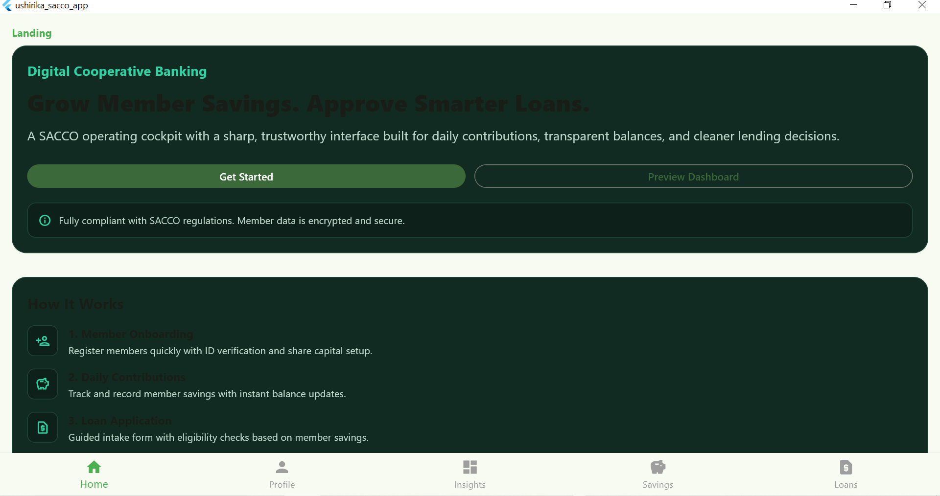

6.2:Profile Screen
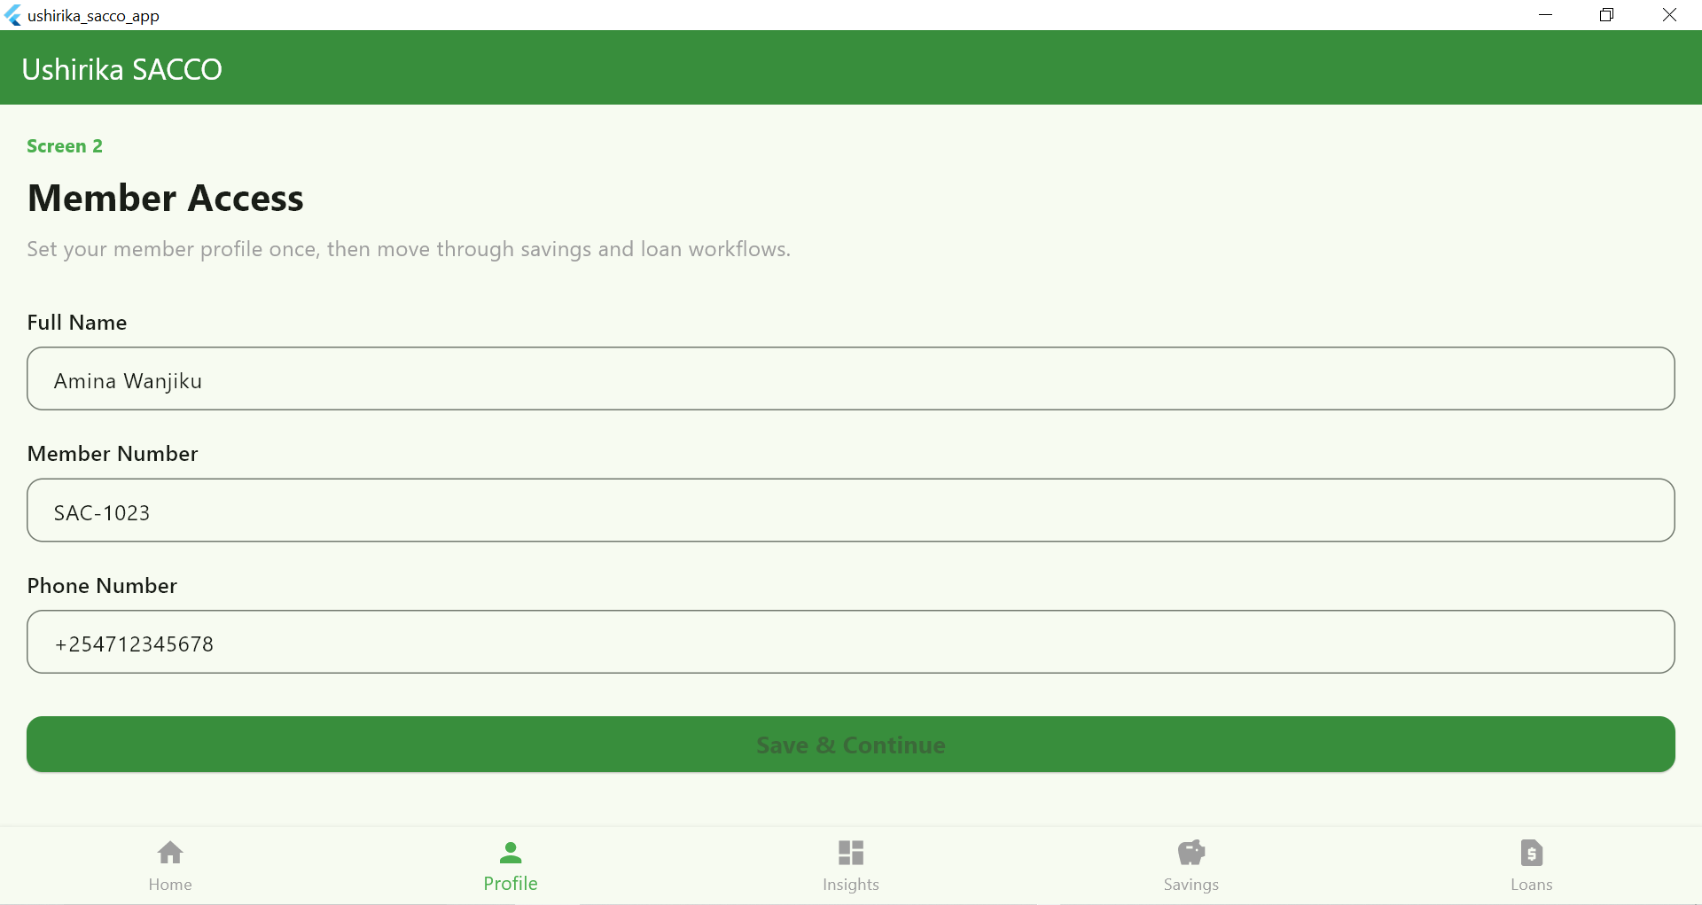

6.3: Insights screen
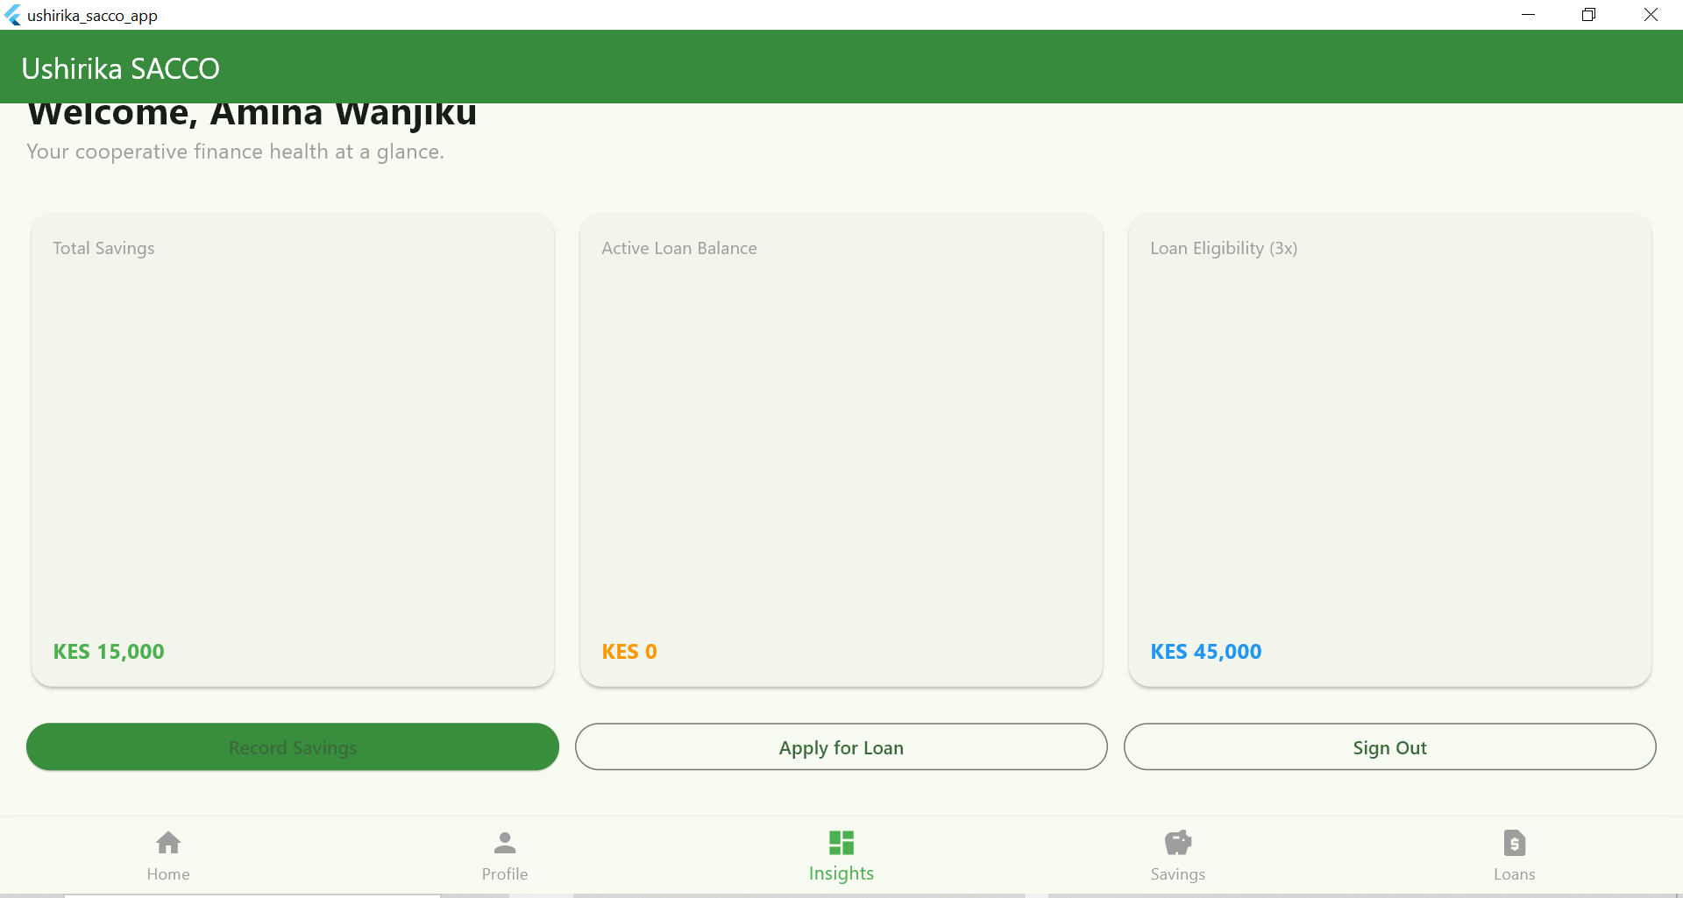

6.4: Savings Screen
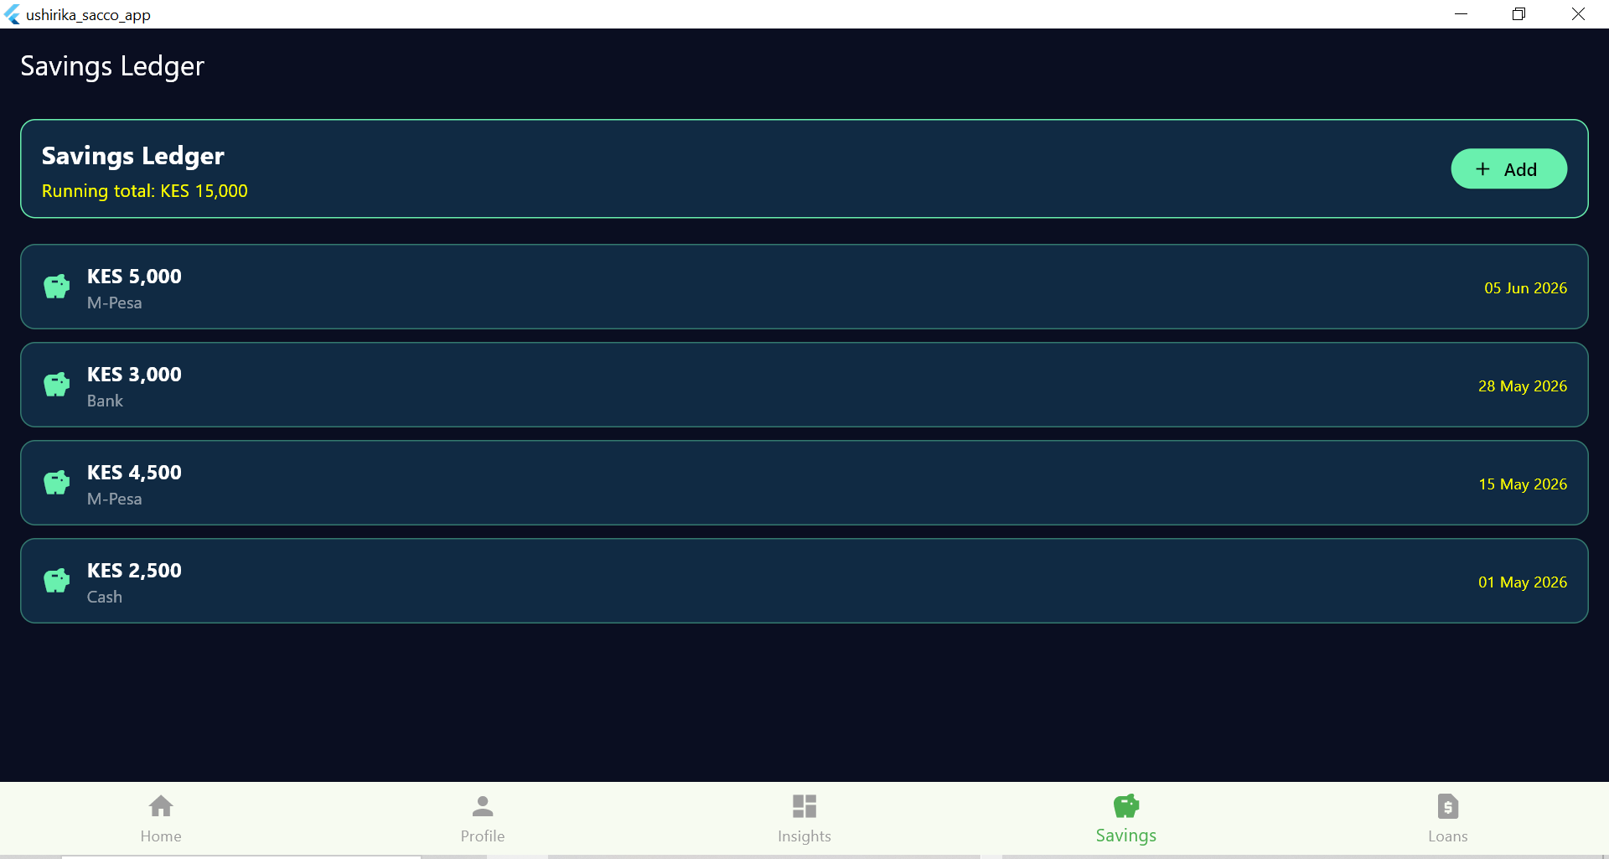

6.5: Loans Screen
